Remainder :-
The mentor suggested me to take demo web shop instead of heroku app .Because the given website is not working as expected. So, I have done as suggested. Hope you will understand and access it.
Registration Functionality :-
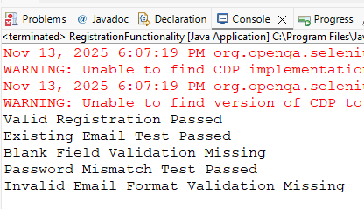

Login Functionality :-
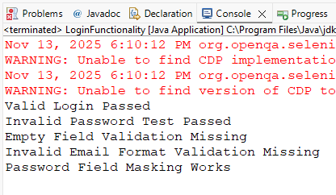

Product and Cart Scenarios :-
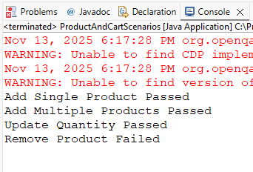
Search and Navigation :-
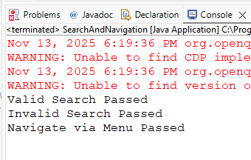
Checkout Scenarios :-
